**PERIO MASTERY FOR HYGIENISTS SERIES PART III:**

***PERIODONTAL THERAPY FROM***

***CURETTES TO LASERS***

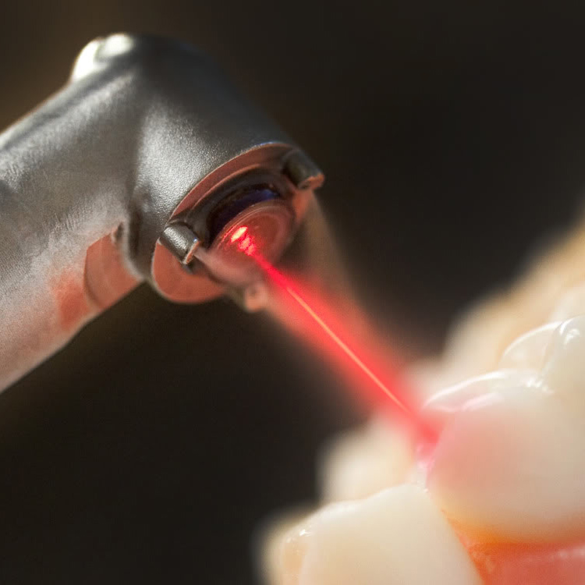

**PRESENTERS:**

**DR. PETER CABRERA & DR. KATE QUINLIN**

**WWW.PERIOIMPLANTCHICAGO.COM**

**$35/Attendee Dinner Included 3 CE Credit hours**

**\*\*\*\* SPACE IS LIMITED \*\*\*\***

**PLEASE RETURN YOUR REGISTRATION TO SECURE YOUR PLACE**

**Wednesday, September 16, 2015**

**Maggiano’s Downtown**

**561 N. Clark Street**

**From 6-9 pm**

**Please join us for the third meeting**

**of the Perio Mastery for Hygienists Series**